



**ElbaHouse–**

**Website Design & DevelopmentProposal**

November6th, 2013



**Espira**

**Tel.** +962 6 4631310,   **Fax** +962 6 4631319

P.O. Box 831382 Amman 11183, Jordan  
[**www.espira.jo**](http://www.espira.jo)



**Letter of Introduction**

Dear Mr.Mohammad,

We would like to thank you for giving us the opportunity to submit a proposal for the design and development of the **Elba House**website. This proposal confirms that we are ready, willing and able to grow our partnership with **Elba House**.

As per our last meeting we have enclosed our revised technical and businessproposal, should you require any further information do not hesitate to contact us. We look forward to a long and mutually beneficial business relationship.

Once again, thank you for this opportunity and we look forward to working with you in the near future.

Yours Sincerely,

YassminShahin

Managing Director



Tel:  +962 6 4631310 ext. 121

Fax: +962 6 4631319

P.O. Box 831382 Amman 11183 Jordan

E-mail: [y.shahin@insightgroup.me](mailto:y.shahin@insightgroup.me)

[http://www.espira.jo](http://www.insight.com.jo/)

**About Us**

**Espira**is a dynamic digital marketing agency that breaks the rules and norms of traditional marketing and creates originality and innovation through our signature rebellious character in Web Solutions, Digital Marketing and Interactive Multimedia.

We believe in creating relevant, engaging, and strategically sound ideas/solutions for our clients through breakthrough thinking and problem solving.

Our mission is to help you construct an on-line image that supports your organizations objectives. Our mission is about fulfilling clients’ needs and desires by delivering the very best solutions.

## **Our Key Competencies**

* *Experience and Expertise*

We have successfully completed numerous projects of different sizes and complexities in various business and technology domains.

* *Commitment to Quality*

#### We are attached to a definite set of quality control measures and under no circumstances would compromise that quality.

* *Fast Delivery*

We are dedicated to complete our projects in the given time frame and can assure you that once you work with us, it will be our main concern to deliver your solution on the defined time.

All members of our team come with many years of experience working in global advertising agencies catering to numerous Fortune 100 companies. Through this background, our team has been able to deploy hundreds of websites and online campaigns.**Some of our Clients**

**Work Samples**



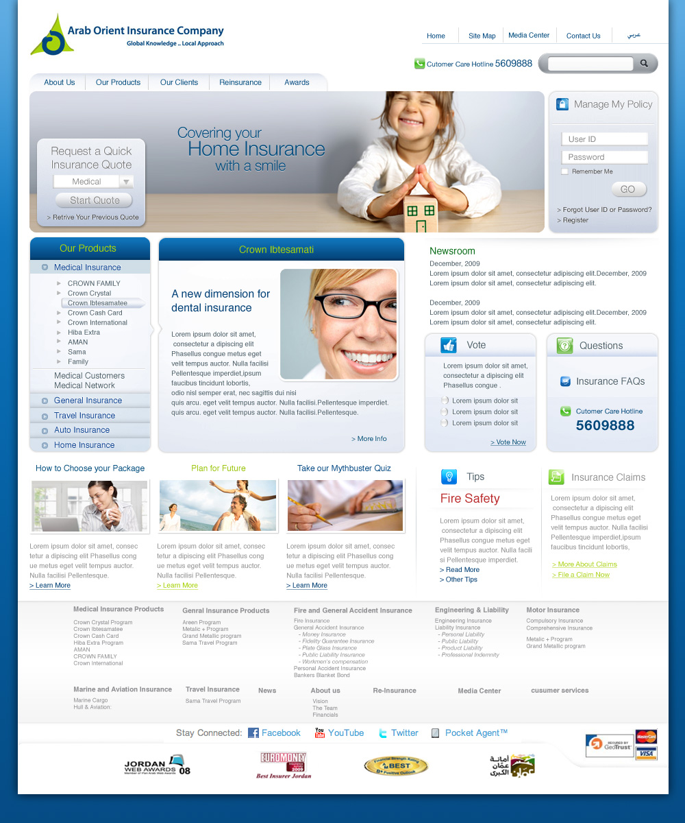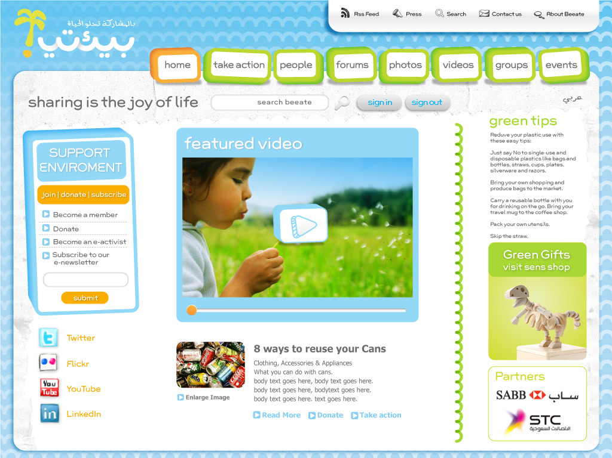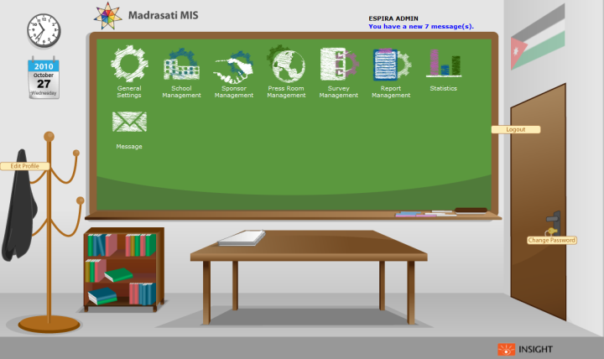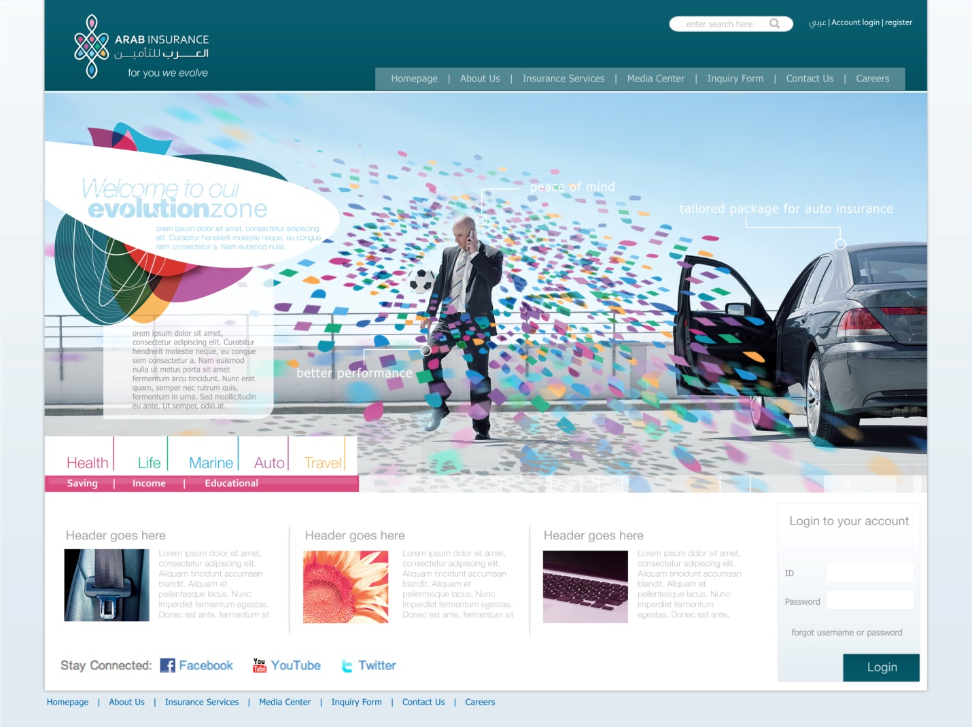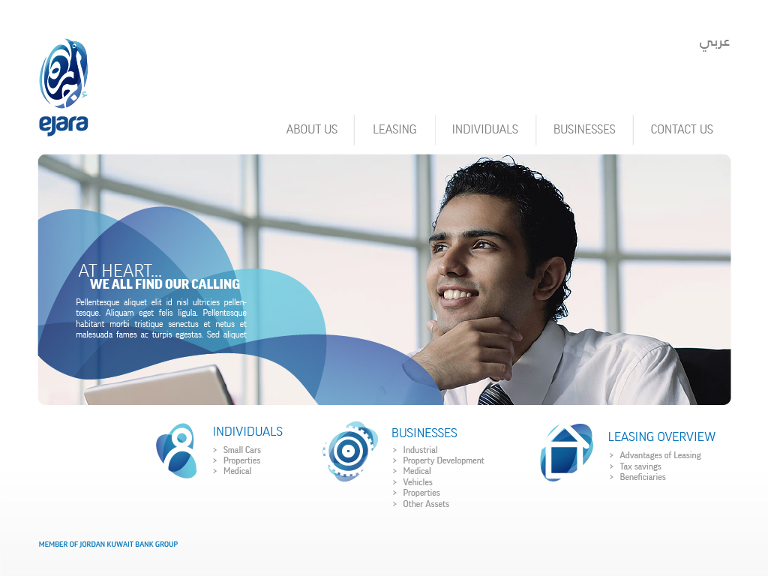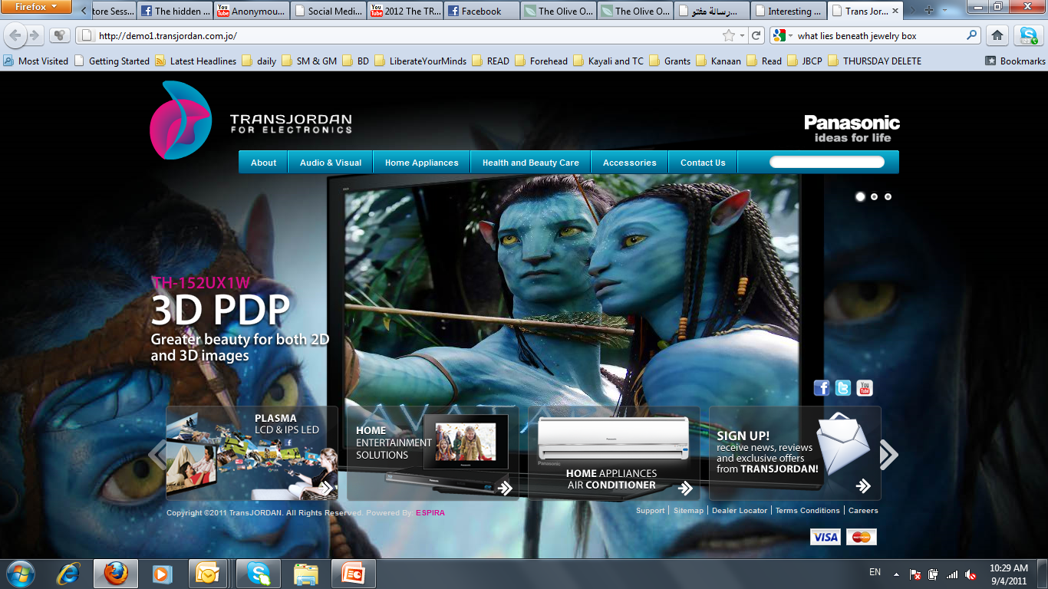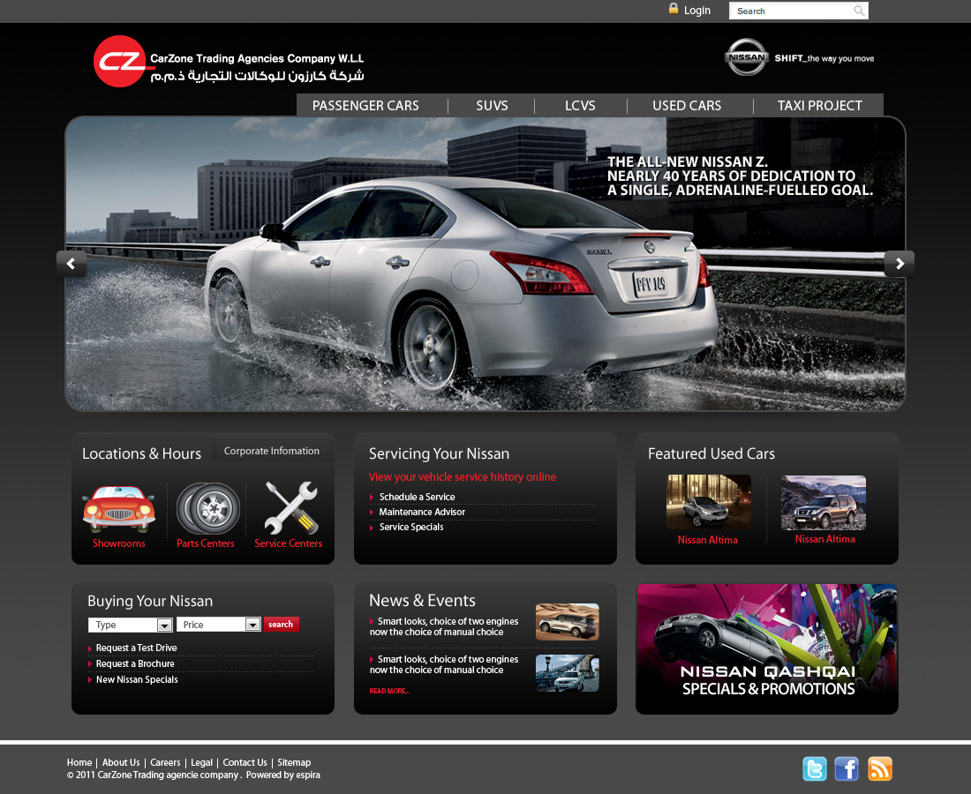

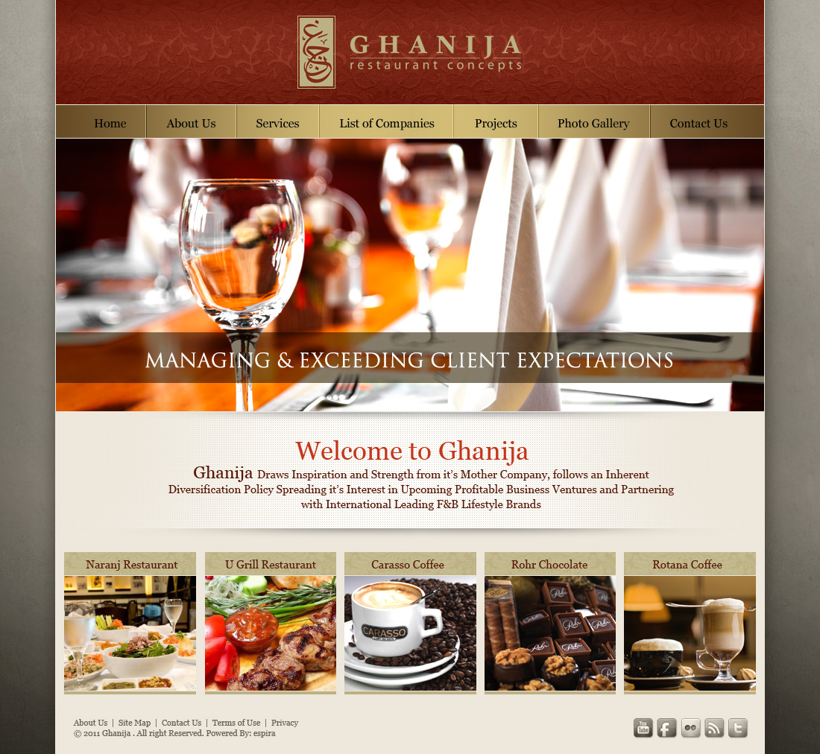

**Current Site Analysis**

The current site is essentially made up of approximately 10 pages which provide information about **Elba House**, its area of expertise, projects and experiences andspecial options.

From a strategic perspective, it is fair to say that although the current website may include useful content it is essential that some additional content be added to make the site more comprehensive and user friendly. As visitors become savvier in using the **Elba House**website, the **Elba House** site leaves some functionality to be desired. The navigation structure is not very clear or well-structured causing some confusion on how to find relevant information needed. From a creative perspective, the design of the site should be revamped to reflect the professional look and feel of **Elba House** and utilize more pictures and vibrant imagery.

The following table displays the current structure of the **Elba House** website:

|  |  |  |
| --- | --- | --- |
| **Tier 1** | **Tier 2** | **Description** |
| Homepage |  | A summary about **Elba House** highlighting its area of expertise |
| Company Profile |  | A brief about **Elba House** |
| Factories |  | A brief about **Elba House** factories & production line |
| Buses |  | Gallery & description of the available buses |
| Custom Made Buses |  | A list of available Custom Made Buses |
| Ambulances |  | A list of available Ambulances |
| Special Options |  | A list of availableSpecial Options like black box … etc |
| News |  | Empty |
| Contact Us |  | Contact us form |

# 

# **Proposed Site: Scope of Work**

The new **Elba House** website should provide a clear idea of **Elba House’s** business focus and expertise. The website will be deployed in 2 different languages: initially starting with English, followed Arabic. The website will be globally advertised under the current **Elba House** domain <http://elbahouse.com>

This proposal serves to outline the requirements for the new **Elba House** website.

The website will be developed in English at first and will serve the following key objectives:

1. Provide clear information about **Elba House** its objectives, mission and vision, organizational structure and members.
2. Position **Elba House** as a trusted and reliable source able to execute various consultancy projects for various sectors worldwide.
3. Provide information about **Elba House’s** various services and industries served.
4. Provide potential visitors with multiple channels of communication to get in touch with **Elba House** (Email, Telephone, Postal Mail, Social Media).
5. Maintain and enforce a professional look and feel for **Elba House**.
6. Be designed in a modular fashion to allow for expansion in the future
7. Provide clearer usability & experience for visitors.

**Proposed Site Structure**

The below table provides the proposed **Elba House** website structure based on a combination of the existing pages found on the **Elba House’**s current site along with our recommendations.

The proposed structure is built on a strategy to categorize information based on user-accessibility, while maintaining the manageable number of primary links so as not to confuse site visitors and allow for future expansion.

It is envisioned that site visitors will not exceed 3 clicks to get from one page of the site to another. A 3 tier category-based navigation will be developed to divide the available information into sections to help visitors quickly identify the information they are looking for by presenting the links in a visually structured manner. The recommended categories also provide room for growth in all navigation tiers to help minimize excessive redevelopment in the future.

It should be noted that the below structure may be re-ordered as production of the website begins as some pages may prove to be better suited to a different category than initially proposed. Any such changes would be recommended to **Elba House** and would require approval prior to being implemented.

|  |  |  |  |
| --- | --- | --- | --- |
| **Tier 1** | **Tier 2** | **Tier 3** | **Details** |
| Homepage |  |  | Homepage featuring the various elements of the website.  See Featured Areas below. |
| Company Profile |  |  |  |
|  | About Elba House |  | An Informative page showing general brief about Elba House |
|  | Our Services |  | An Informative page Shows details about Elba House main services |
|  | History |  | An Informative page contains brief about Elba House history |
|  | Vision & Mission |  | An Informative page contains Elba House vision & mission |
|  | Organizational structure & Members |  | An Informative page contains the organizational structure of Elba House company & listing of the key members |
|  | Factories |  | This Informative page contains a full description about Elba House factories |
| Products |  |  |  |
|  | Buses | Description, Gallery & Attachments (PDF reader) | List of products in buses category (could contains subcategories) |
|  | Ambulances | Description, Gallery & Attachments (PDF reader) | List of products in Ambulances category |
|  | Black Box | Description, Gallery & Attachments (PDF reader) | List of products in Black Box category |
|  | Multiplex System | Description, Gallery & Attachments (PDF reader) | List of products in Multiplex System category |
| Custom Made Buses |  |  | A section where client can create and develop his own custom made buses upon his needs, by few and easy steps |
| Clients & partners |  |  | list of Elba House clients and partners with some information about each one |
| Media Center |  |  | Contains a gallery of images & videos for Elba House |
| News Center |  |  | Contains the latest news of Elba House Company |
| Contact Us & Location Map |  |  | Contains enquiry form & all contact info along with directions map for the company location |
| Careers |  |  | Contains a form where users can apply for a vacancy & submit their CVs |
| **Secondary Links** | | | |
| Sitemap |  |  | Sitemap page (the main |
| Privacy Policy |  |  | Privacy Policy page |

*App**roximate Number of Pages: 100 (may increase or decrease depending on the number of project pages)*

***\*The site structure above can be amended according to Elba House continuous feedback throughout building the website. More pages can be added without extra charge.***

## ***\*All pages of the website may include sharing tools for the Elba House website to be easily shared by visitors to social networking sites such as Facebook, Google+, Twitter and others if desired.***

## **Site Creative Strategy**

The objective of the creative strategy is to represent **Elba House** as a reliable and trusted source fully capable of executing various consultancy projects in various sectors. This objective will be achieved through relevant imagery and content that showcases **Elba House’s** area of expertise.

###### Imagery

The imagery selected for the website will be based on available images from **Elba House** and/or online image sourcing.

**Design Development**

**Elba House** will be presented with a homepage design and once approved; the key site templates for the internal pages will be developed as creative extensions of the approved site home page.

The design of Elba House website will be responsive; That means it will adapt in any screen resolution such as Desktops, Laptops, Tablets and Mobiles. The responsive design and the similarity in design will improve the user experience and usability.

**Content Management System (CMS)**

All the content of the website pages & posts can be controlled by the website admin through adding, editing & deleting any of these content easily as simple as editing the content in microsoft word.

The CMS contains a Media Center to manage both the photo and video galleries of the website.

Another main feature of the CMS is menu control. This allows the admin to control all the main menus in the website such as the Main and Footer Menus. where the admin can add, edit or delete menu items; for example adding a new section to the main menu and assign different pages and sections to it.

**Site Features**

**Basic Features**

* **Company Profile**Company profile contains brief about the Company, Services, History, Vision and Organizational Structure.
* **Dynamic Informative Pages**  
  The CMS allows the admin to add a new informative page easily through the admin panel and link it to the website, and fill it’s content.
* **Factories**This page contains a full description about Elba House factories, their history, technology used and the operation & production process adopted in the factories.
* **Products & Categories**The user can browse your products according to their categories, each product will have a list of details & description in addition to attached files & brochures and interactive photo gallery for each product.
* **Contact Us & Location Map**Contains an enquiry form that allows the users to send you a question or any request. Also it contains your contact info along with directions map for the company offices & factories locations.
* **Clients & partners**A list of your clients will be displayed in this page with some information about the clients and partners of Elba House.
* **SEO**SEO stands for “search engine optimization”. It is the process of getting traffic from the “free,” “organic,” “editorial” or “natural” listings on search engines such as Google, Yahoo and Bing. SEO can make the content of your web pages more relevant, more attractive, more easily read by search engines and increase the rank of your website in search engines results.

**Advanced Features**

* **Multilingual Feature**The website will be displayed in English & Arabic. The user can switch between the two languages easily.
* **360° View**  
  The 360° view allows the user to see the products in an interactive rotating high quality 360° photos unlike the static photos, giving the user the ability to navigate more detailed & closer view for the products.
* **PDF reader flip page**The pdf reader flip page allows users to view pdf’s in an quickly & attractive way without the need to leave your website.
* **Careers**Careers sections are one of the most visited pages for many companies. It is a very effective tool used to communicate to potential and current employees allows them to apply to the available vacancies and upload their CVs using the careers form.
* **Media Center**  
  The media gallery will display the images & videos of your company, categorized by type and date, displayed in a simple yet elegant style with optical zoom feature to show the fine details of images.
* **News Center**By this section you can post the news of your company to keep the clients updated with the latest news, the news will be categorized by year and type to help the users to navigate easily.
* **Custom Made Buses**This section will help the client to create and develop his own custom made buses upon his needs, by few and easy steps. After sending the request you will receive a full detailed and structured report for the required options & features.
* **Social Media Connection**Elba House website will be connected to your accounts on social media such as Facebook, Twitter, Google+, YouTube and Linkedin. Also the website will contains the share box feature to share the content & products in the social cloud. social media is a great way to improve the marketing operation and increase the website traffic to attract new customers.
* **Feedback & Reviews**Feedback is a powerful tool that helps you get on track, it considered as a guide to assist you & your clients to know more about your performance. People like to feel involved and identified with their organization. Through this feature the users can share their reviews & opinions on your products. These reviews will be monitored and controlled by the admin to prevent any undesired comments.
* **Best Sold & Featured Products**The featured products will be shown in a dynamic rotator on the homepage; this will give these products more views. Any product can be set as featured by the admin to be shown in this section.
* **Website Search Engine**The users can search for any product or content in the website using powerful integrated search engine.
* **Online Support & Live chat**To improve customer support services and fast response, Live chat allows users to contact directly with your customer support officers to provide real time support.
* **Statistics & Reports**The admin can view a detailed reports & statistics about the website visitors, that give the amount of visitors and hits daily, monthly & yearly and the countries of visitors and a lot of information about each visitor.
* **Newsletter & Mailing List**It allows you to send periodic newsletter & offers for the subscribers with Elba House through your website.

# **Project Timeline**

Pending further discussion with **Elba House** to further define the final scope of work, Espira estimates that the deployment of the English website will require a period of 2 months from the date of approving the final scope of work, website design and templates.

*Note: A separate document will be provided to* ***Elba House*** *with further details as to the overall project plan and timeline. Depending on factors such as* ***Elba House*** *final requirements, content delivery, feedback throughout the project, launch dates could be moved up or delayed.*

# 

**Website Technologies**

Elba House website will use the following technologies:

* PHP 5.3+
* MySQL 5.5+
* HTML5
* CSS3
* JavaScript

The website will be built over WordPress CMS framework, which is a PHP platform. Using This framework will guarantee using the international standards for development and security. The CMS will be built in such a fashion to allow users who are comfortable with using Microsoft Word to perform updates on the **Elba House** website.

Espira’s team has successfully deployed similar CMS applications to global clients such as Arab Orient Insurance, Al Jazeera Travel, and Kirresh Group. The CMS requires a web browser and a connection to the Internet to login and manage.

# **Hosting & Operational**

**Hosting Environment**

It is assumed that **Elba House** would provide Espira with full FTP access to its web server in order to test, deploy, and maintain the **Elba House** website.

An optimal server environment would meet the following specifications:

|  |
| --- |
| Web Server  Apache  PHP 5 Engine |
| Database  MySQL |

# 

# **Maintenance & Content Updates**

Espira will provide maintenance and content updates for a period of 1 month after the final website is approved on a complimentary basis.

*Note: Maintenance pricing is included in the financial offer document*

**Budget**

The cost for the development of the **Elba House**website is outlined below. Changes in the project scope can affect the budget as outlined. The budget can be broken down as follows:

**Development of English Website**

|  |  |
| --- | --- |
| **Description** | **Budget (USD)** |
| Strategy, Project and Production Management | Complimentary |
| Creative Development:  Creative strategy; Designing Wireframes; design and development; Identifying font styles for the website; Development of the home page layout and key inside templates, Images sourcing, optimization, and manipulation; Photo editing and resizing of all image; Web design; Testing & Evaluation | 4,500 |
| Full CMS (Basic Features)   * Company Profile * All Informative Pages * Products & Categories * Contact Us & Location Map * Clients & partners * SEO |  |
| Advanced Features   * Multilingual Feature * 360° View * PDF reader flip page * Careers * Media Center * News Center * Custom Made Buses * Social Media Connection * Feedback & Reviews * Best Sold & Featured Products * Website Search Engine * Online Support & Live chat * Statistics & Reports * Newsletter & Mailing List | 9,750 |
| CMS Training  3-day CMS training sessions for **Elba House** team. | Complimentary |
| **Total Development:** | **14,250** |

**Annual Maintenance (Optional)**

|  |  |
| --- | --- |
| **Description** | **Budget (USD)** |
| Monthly Updates for One Year  Retainer would include the following:   * Addition, editing, and deletion of pages based on existing templates in the CMS system; Updates and design of new images and animations to replace existing images/animations on website. * Design and creation of any promotional HTML emails (send out costs are not included in the retainer and will be billed separately if service is required by **Elba House**) * Design and creation of banner promotions   Retainer does not include the following:   * Major updates to the CMS (i.e. integration with a new system) * Creation of multi-media CD’s/Presentations * Print material design * Additional language expansion * Translation/Copywriting costs * 3rd party costs * Adding new features to the site | 5,250/year |
| **Total:** | **5,250** |

***\* Please note that each project phase will be dealt with as a sub-project with its own dynamics, project timeline and invoice.***

Terms & Considerations

* The budget in this document has been presented based on the project as outlined in the proposal. Changes to the site requirements may increase or decrease the associated budget.
* The budget excludes any sales tax or VAT which will be added to the final cost quotation if required.
* The budget does not include any 3rd party costs
* The budget does not include any costs for content authentication service.
* Budget does not include hosting of the **Elba House** website
* Should Espira be awarded the development of the **Elba House** website, Espira will present **Elba House** with a payment schedule per language.

# **Confidentiality**

As this work requires us to be involved in confidential aspects of your business, we understand that all work is to be held in strictest confidence and used for the purposes of executing this proposal for the [**Elba House**](http://idrc-jo.com/contact.php)**(Elba House)** only. Espira will comply with any rules and regulations set forth by **Elba House’s** non-disclosure agreement.